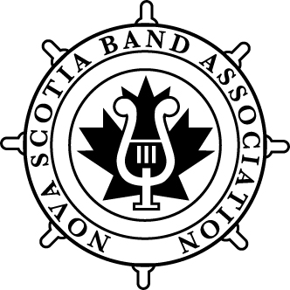
Nova Scotia Band Association
Annual General Meeting
Wednesday, March 19, 2025
7:00pm
Virtual Meeting via Zoom

- Call to Order

- Review of Minutes from 2024 https://docs.google.com/document/d/1mlEJeVXv5cEZikpApXq7oonyAkpPlvR4fBadgpTwQsY/edit?usp=sharing

- By-laws revision – Hope Gendron

- Election of Officers – Steve Hartlen

Election of Officers 2025

President Dina Burtt
1ST Vice President John MacLeod
2nd Vice President (PEI) Holly Leader
Treasurer Jackie Crowell
Secretary David Burtt

Member at Large Mellisa Ashley
Member at Large Amanda Mark
Member at Large Helen Bannerman
Member at Large Jacob Caines
Member at Large Serena Godmaire
Member at Large Sarah MacDonald
Member at Large Alison Meadows Peters
Member at Large Lyndsey Mitchell
Member at Large Allison Penwell

Community Band Representative David Prince
Community Band Representative Ken Henderson

NSYWE Hope Gendron
NSJWE Holly Hartlen
NSHJ Nick Fisher

  - Managing Director until April 30, 2025 Hope Gendron

- President’s Report – Dina Burtt

- Financial Report – Jackie Crowell

- Managing Director's Report & Membership Report – Hope Gendron

- NSBA Project Reports

  - Atlantic Festivals of Music
  - NSYWE
  - NSJWE
  - NSHJ

- Appointment of auditors – Dina Burtt

- Motion to adjourn

